ANNEX

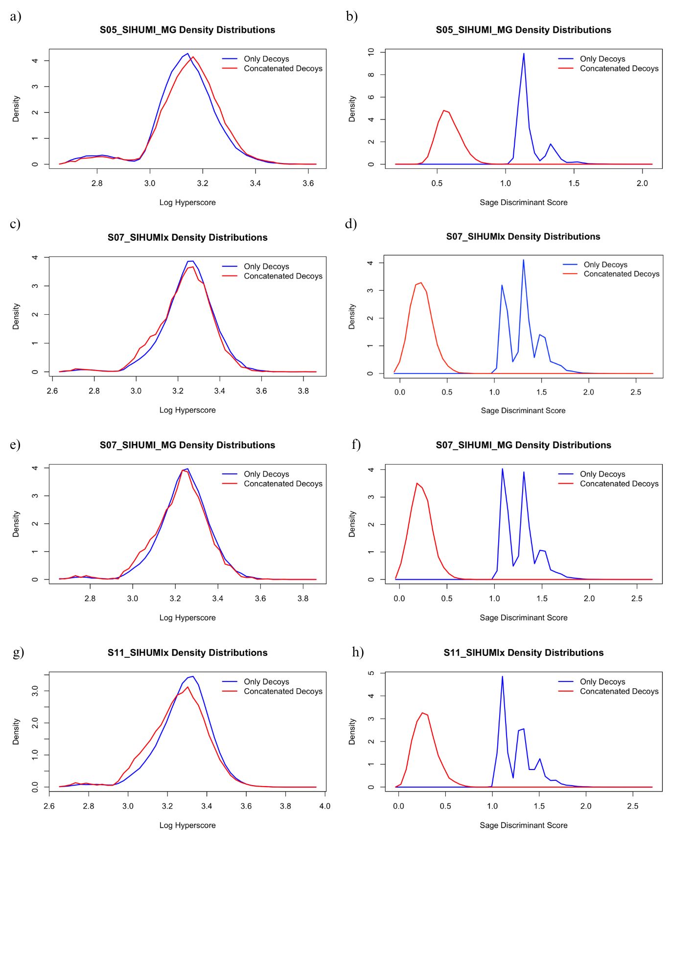*Figure A1. Density distributions of only-decoy (blue) searches and concatenated (red) searches. Left panels show the log hyperscore density, right panels show the Sage discriminant score density.*

*Figure A1. Continuation.*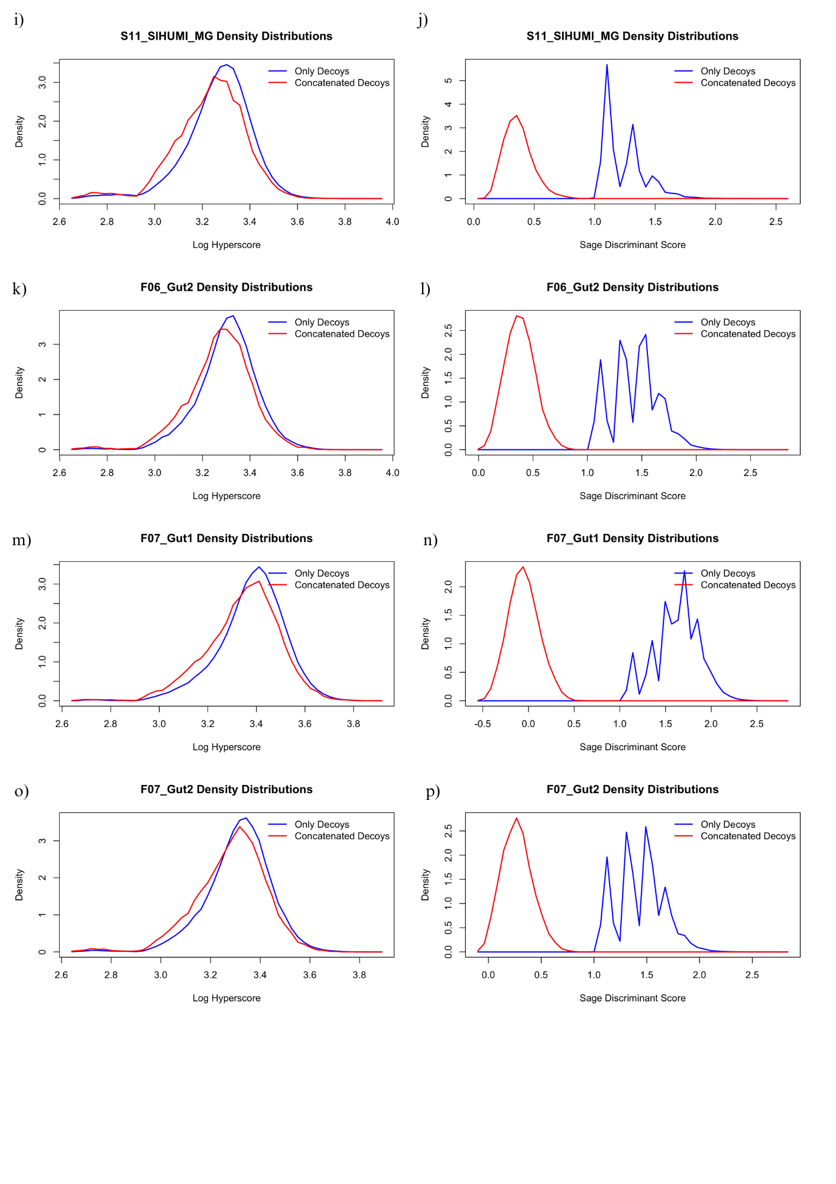

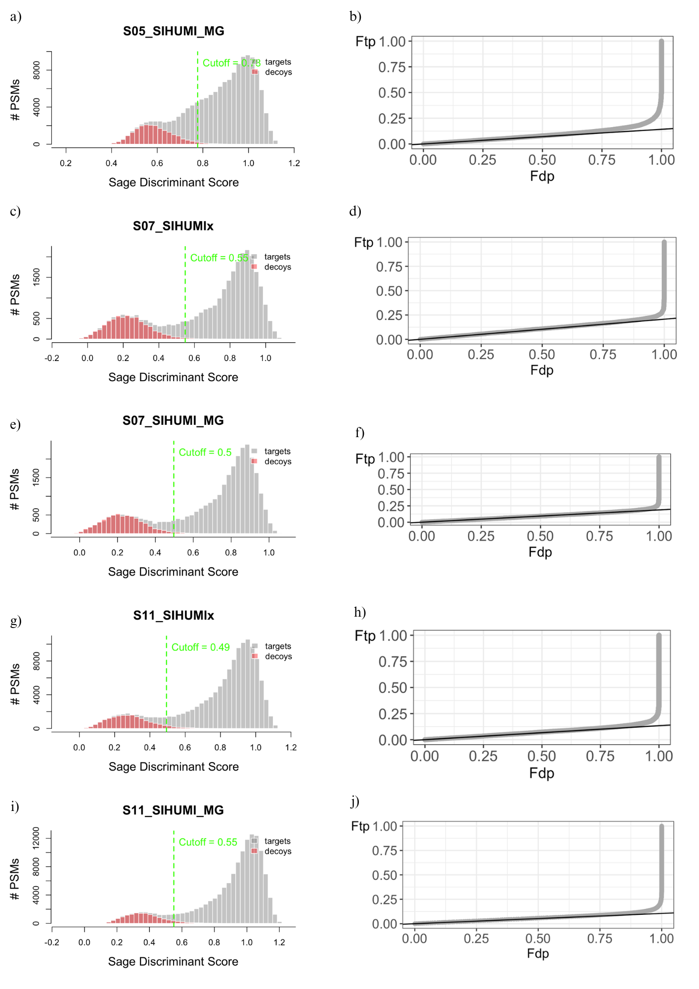

*Figure A2. Diagnostic plots for all the samples except S05_SIHUMIx (in the main text). Left: Histogram of target (grey) and decoy (red) PSMs based on the sage discriminant score. Right: PP plot using the sage discriminant score.*

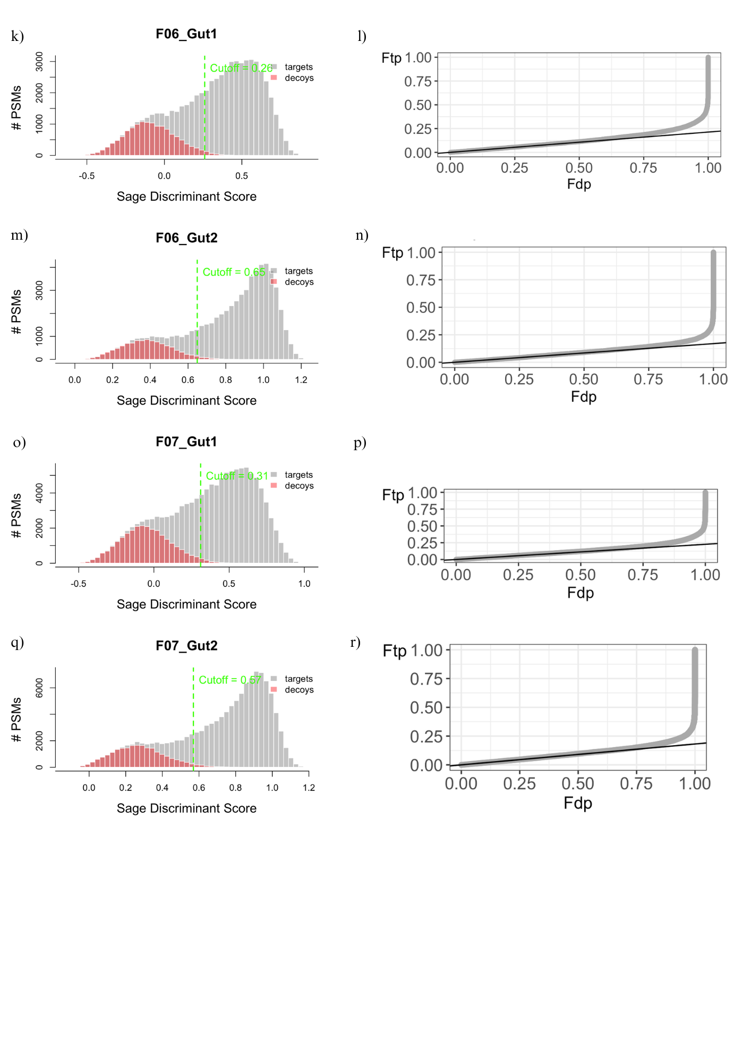

*Figure A2. Continuation.*

*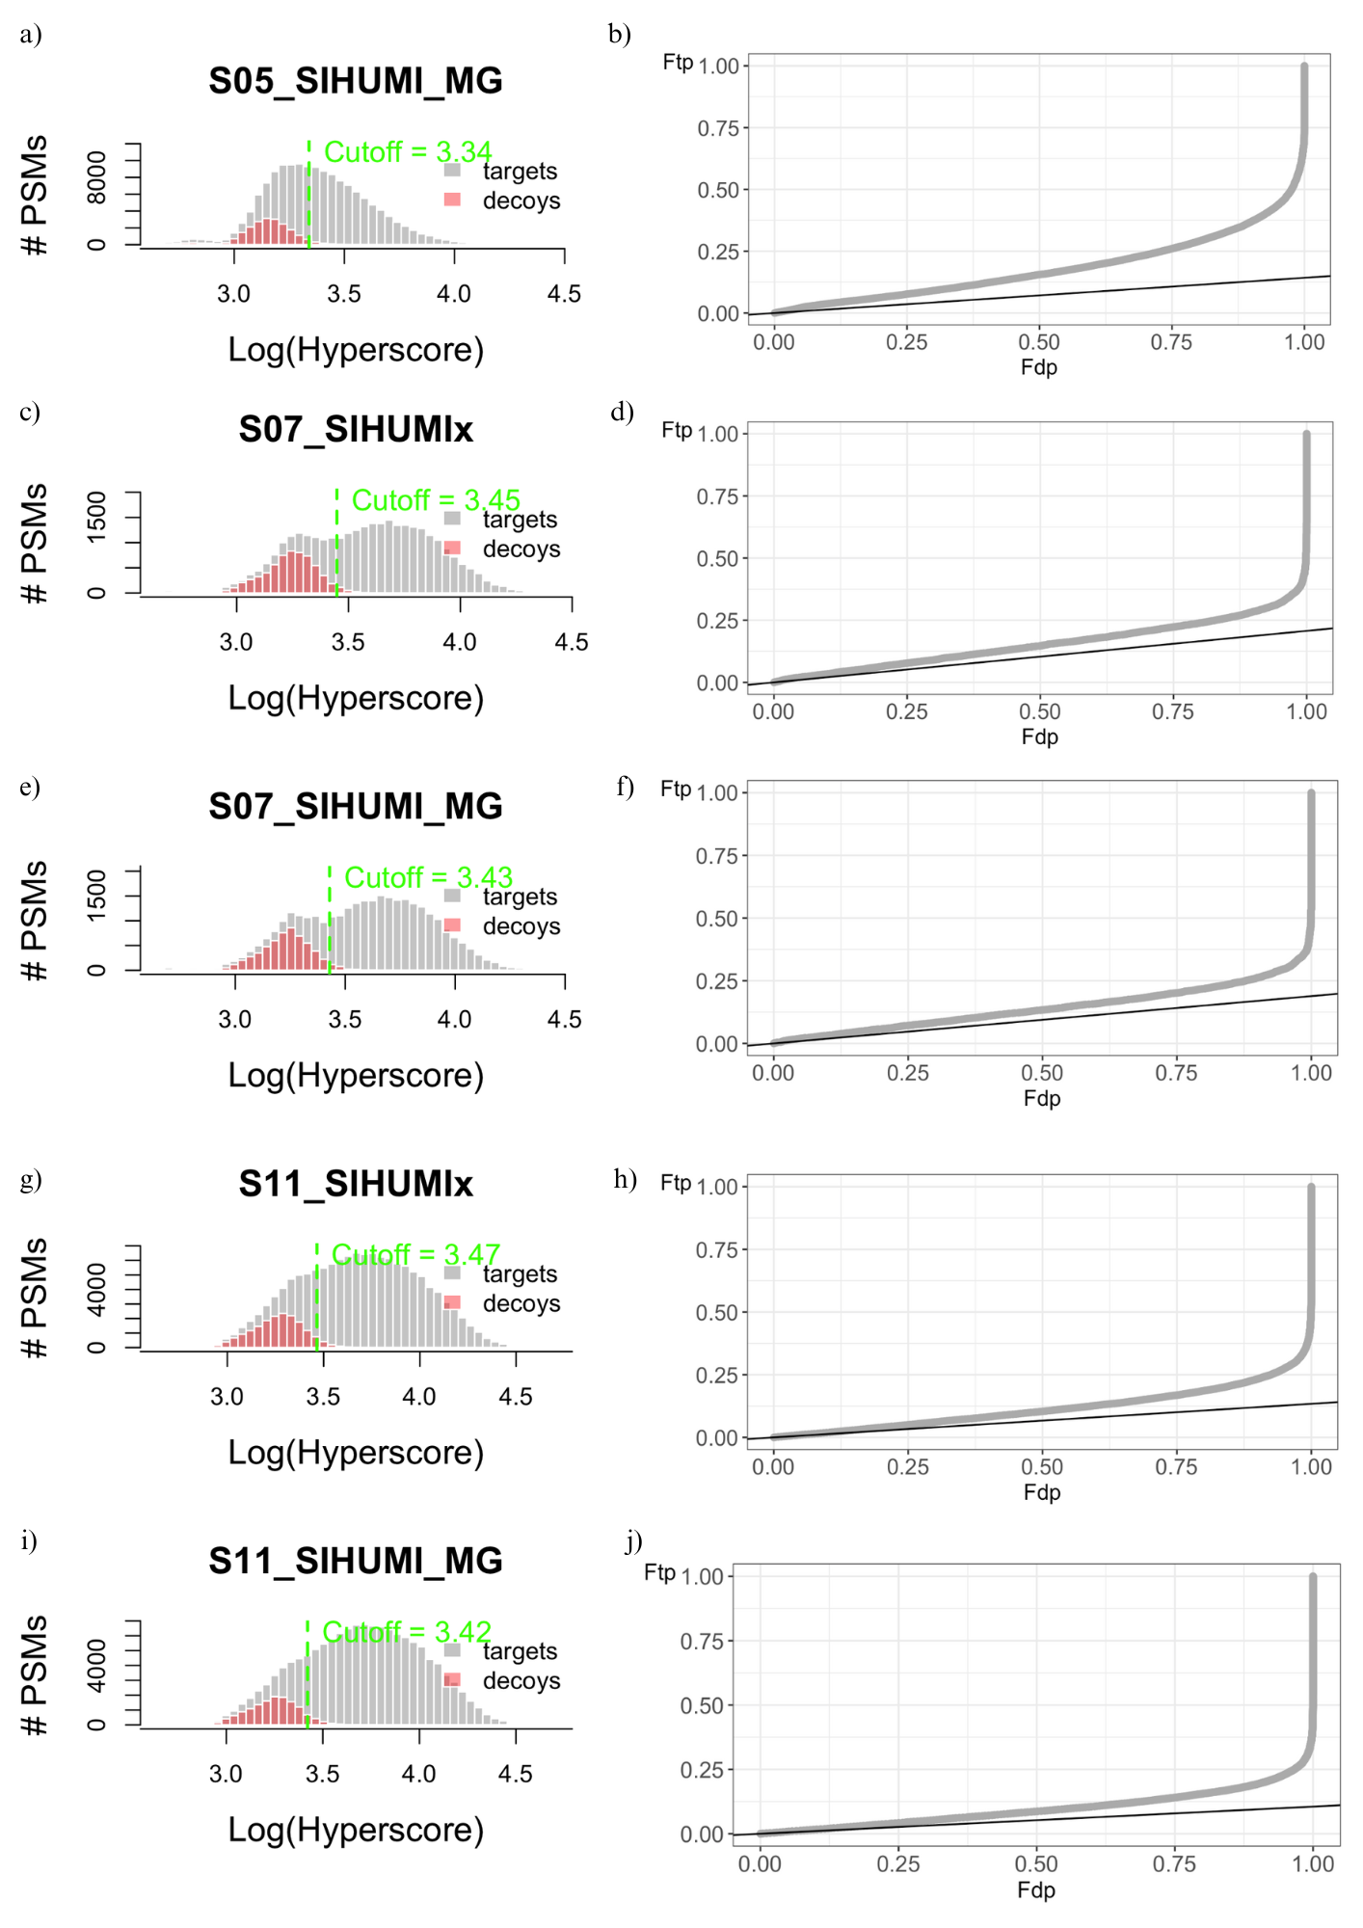 Figure A3. Diagnostic plots for all the samples except S05_SIHUMIx (in the main text). Left: Histogram of target (grey) and decoy (red) PSMs based on the log(Hyperscore). The FDR threshold is indicated in green. Right: PP plot using hyperscore.*

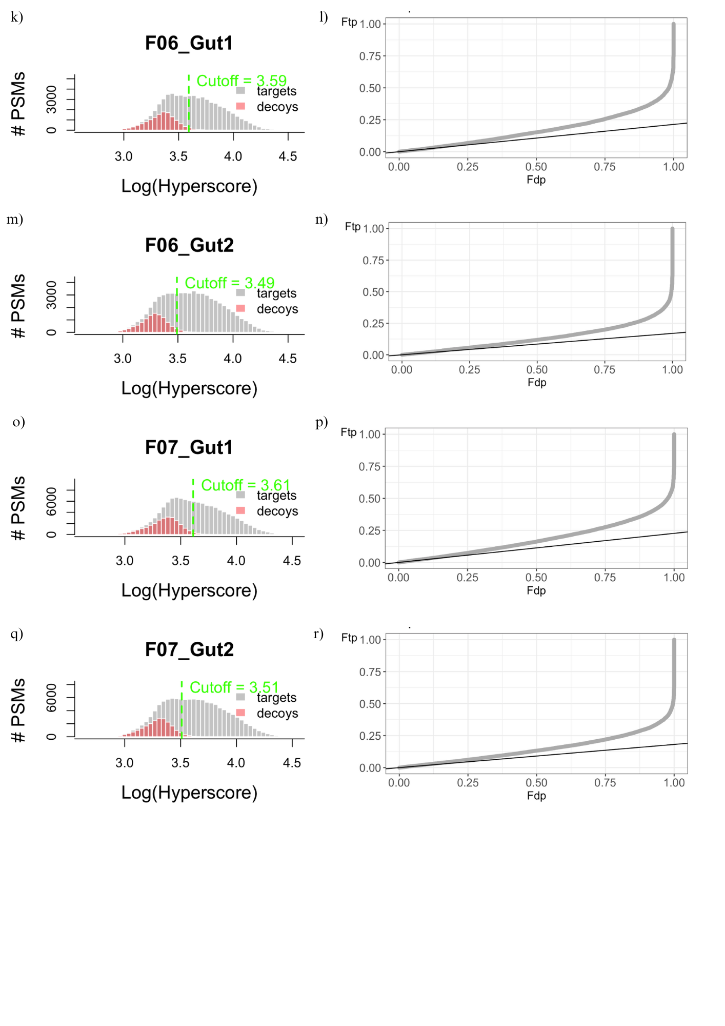

*Figure A3. Continuation.*

*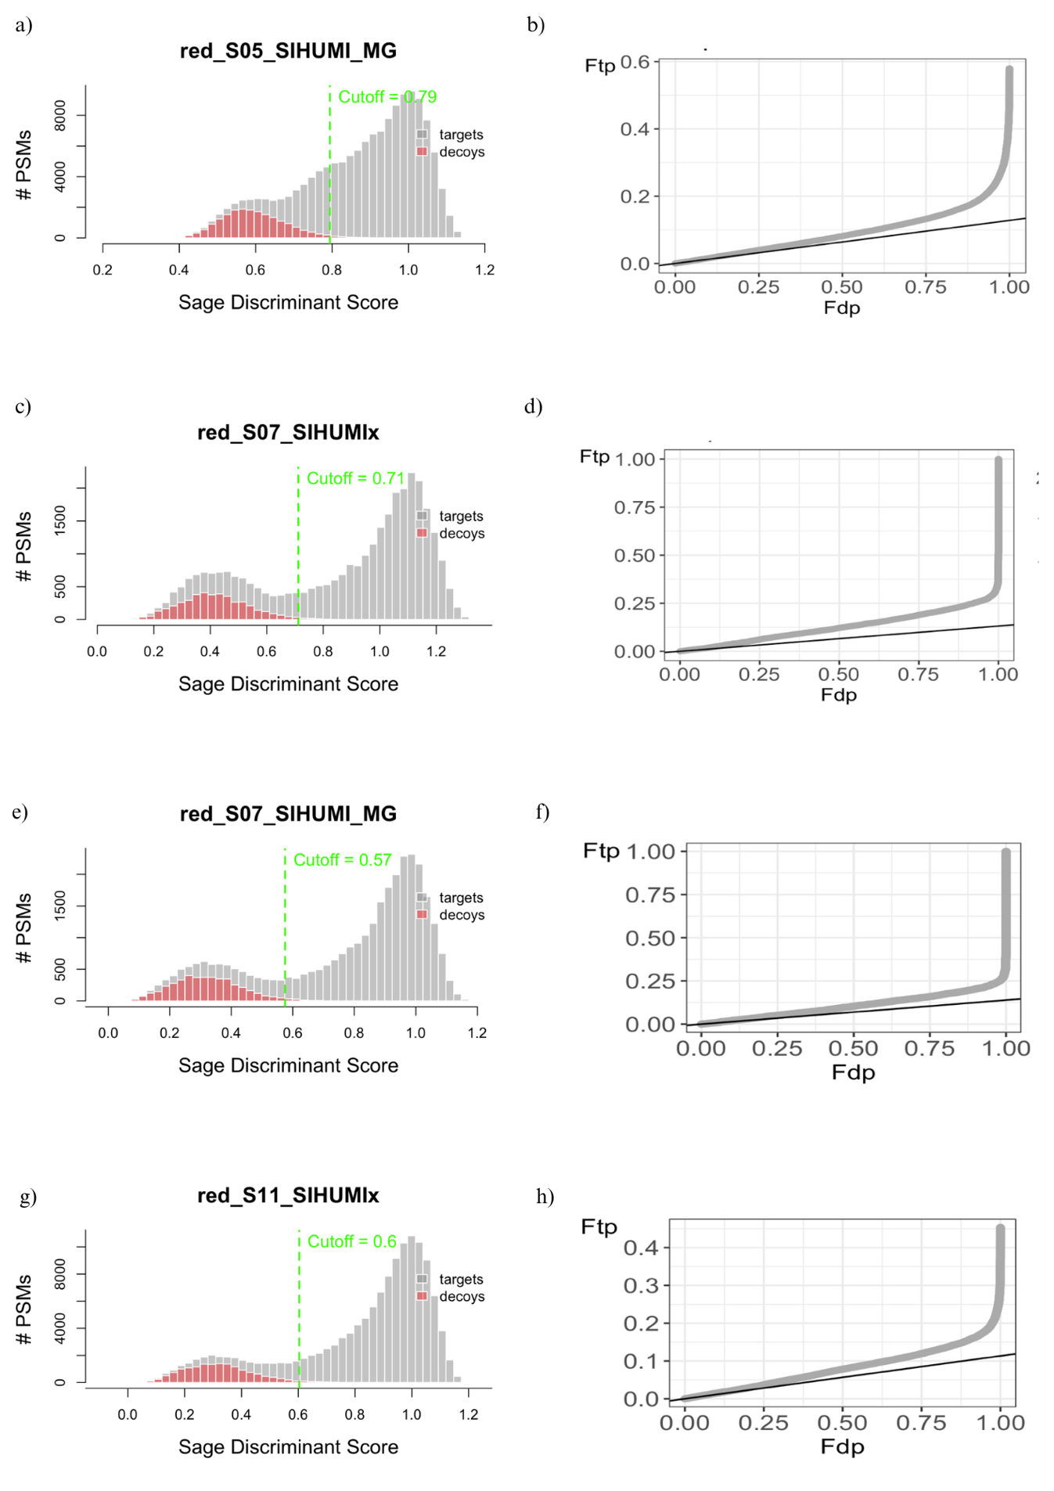Figure A4. Diagnostic plots for all the samples after database reduction, except S05_SIHUMIx and F06_Gut1 (in the main text). Left: Histogram of target (grey) and decoy (red) PSMs based on the Sage discriminant score The FDR threshold is indicated in green. Right: PP plot using the Sage discriminant score.*

*Figure A4. 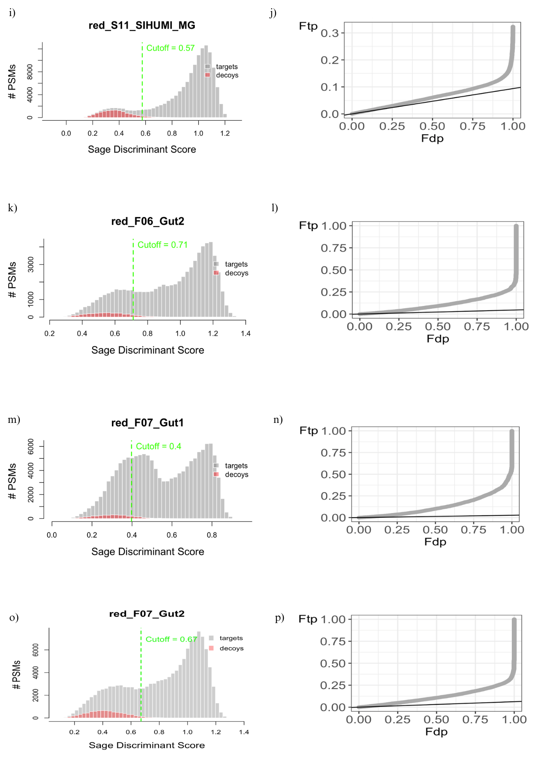Continuation.*

*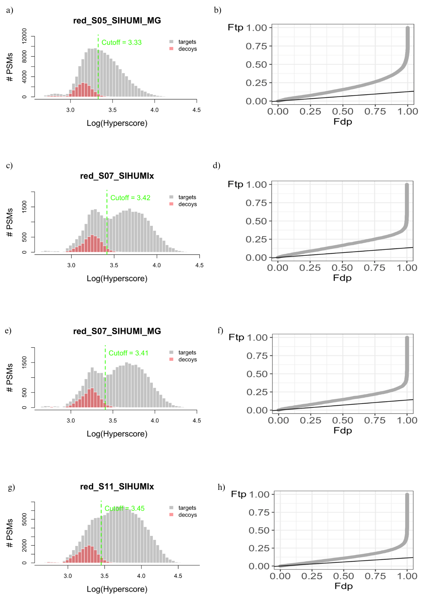Figure A5. Diagnostic plots for all the samples after database reduction, except S05_SIHUMIx and F06_Gut1 (in the main text). Left: Histogram of target (grey) and decoy (red) PSMs based on the log(Hyperscore) discriminant score The FDR threshold is indicated in green. Right: PP plot using the Hyperscore.*

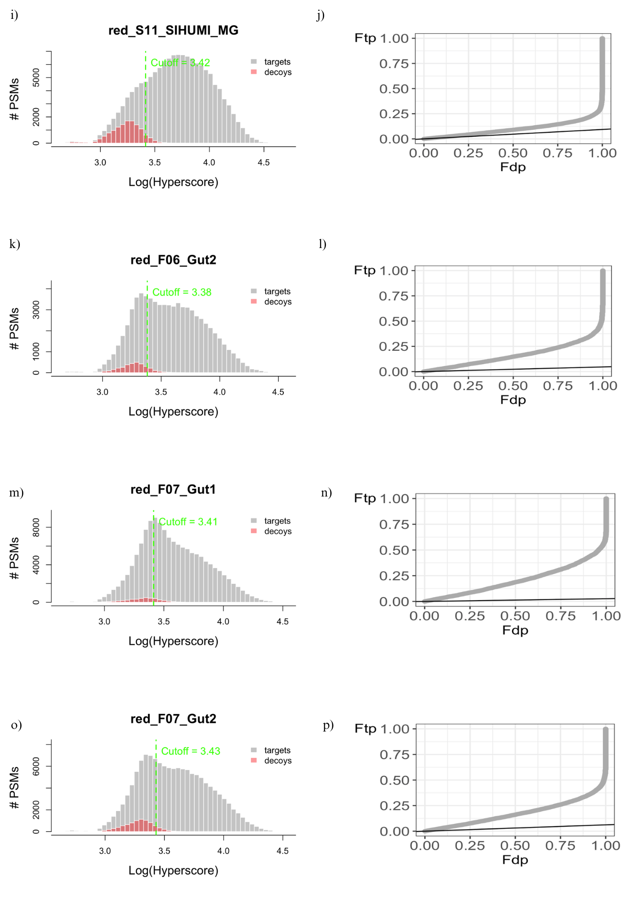

*Figure A5. Continuation.*

*Table A1. Comparison of identifications between reduction at protein and peptide. The reduction factor was calculated as the quotient between the number of unique tryptic peptides in the protein FASTA divided by the ones in the peptide FASTA.*

|  |  |  |  |  |  |
| --- | --- | --- | --- | --- | --- |
| Sample ID |  | Database | Unique tryptic peptides in protein FASTA | Unique tryptic peptides in peptide FASTA | Reduction Factor |
| Mock community |  |  |  |  |  |
| S05 |  | SIHUMIx | 335210 | 59203 | 5,66 |
| SIHUMI_MG | 251888 | 51076 | 4,93 |
| S07 |  | SIHUMIx | 232307 | 25591 | 9,08 |
| SIHUMI_MG | 179222 | 24177 | 7,41 |
| S11 |  | SIHUMIx | 349271 | 55257 | 6,32 |
| SIHUMI_MG | 241282 | 49649 | 4,86 |
| Fecal samples |  |  |  |  |  |
| F06 |  | Gut1 | 2929532 | 48528 | 60,37 |
| Gut2 | 800984 | 42972 | 18,64 |
| F07 |  | Gut1 | 3801849 | 73740 | 51,56 |
| Gut2 | 1132843 | 62372 | 18,16 |

*Table A2. Comparison of the empirical FDR results for different databases search strategies: reduction at protein level and reduction at peptide level.*

|  |  |  |  |  |  |  |
| --- | --- | --- | --- | --- | --- | --- |
| Sample ID | Protein - Reduced Database | | | Peptide - Reduced Database | | |
| #Decoys | #Targets | Empirical FDR | #Decoys | #Targets | Empirical FDR |
| Mock community | | | | | | |
| S05_SIHUMIx | 23635 | 147158 | 0,16 | 10089 | 120853 | 0,08 |
| S05_SIHUMI_MG | 19149 | 149502 | 0,13 | 9024 | 120305 | 0,08 |
| S07_SIHUMIx | 4316 | 32833 | 0,13 | 4416 | 26924 | 0,16 |
| S07_SIHUMI_MG | 4495 | 32360 | 0,14 | 4520 | 26233 | 0,17 |
| S11_SIHUMIx | 15574 | 137209 | 0,11 | 19586 | 105646 | 0,19 |
| S11_SIHUMI_MG | 13000 | 138657 | 0,09 | 18813 | 103821 | 0,18 |
| Fecal samples | | | | | | |
| F06_Gut1 | 1711 | 76142 | 0,02 | 5089 | 63404 | 0,08 |
| F06_Gut2 | 3374 | 72858 | 0,05 | 5685 | 60705 | 0,09 |
| F07_Gut1 | 3864 | 142474 | 0,03 | 11127 | 119087 | 0,09 |
| F07_Gut2 | 8412 | 134585 | 0,06 | 12866 | 112517 | 0,11 |

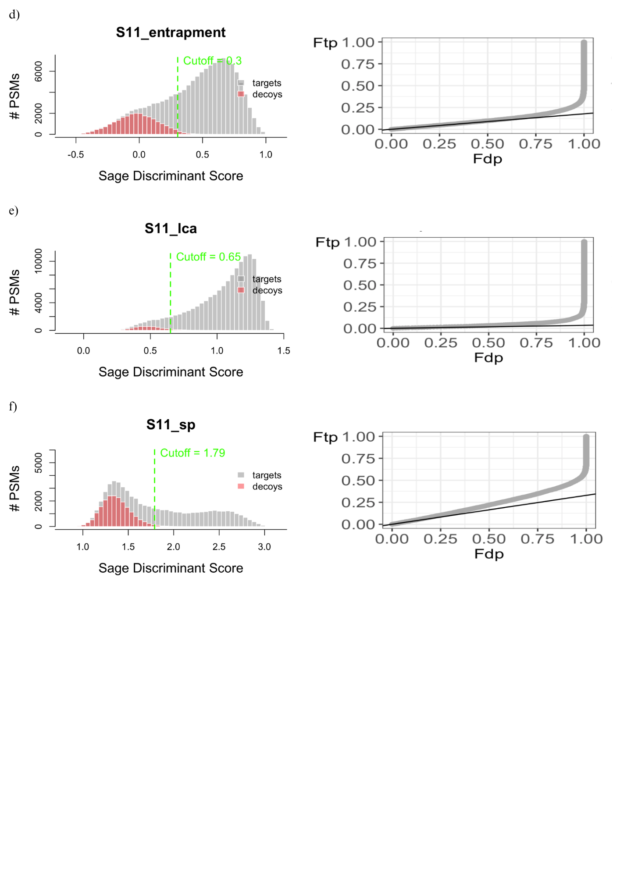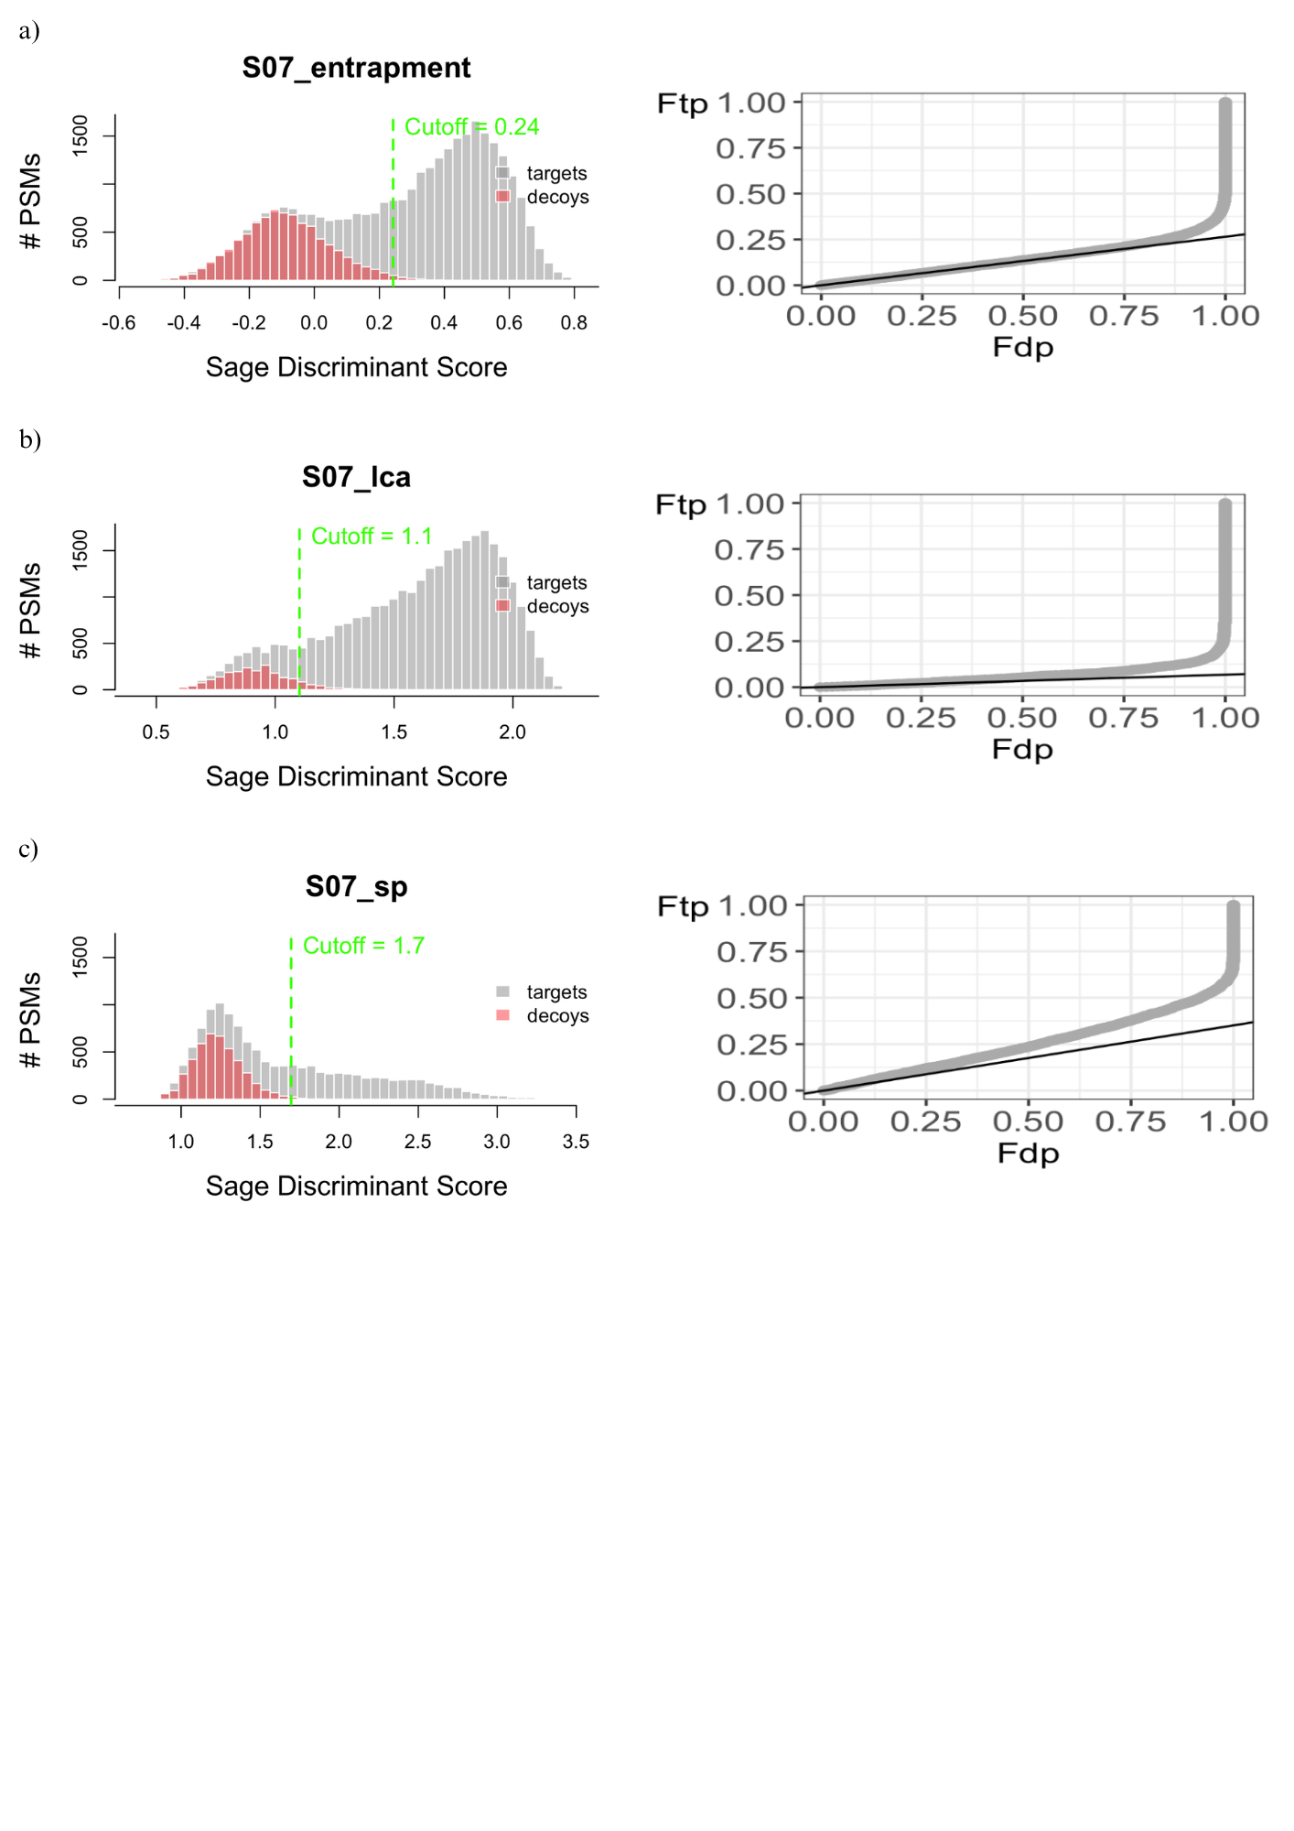

*Figure A6. Diagnostic plots for samples S07 and S11 assessing the effect of entrapment (a and d), reduction based on LCA reduction (b and e) and reduction based on species-level (c and f) on the FDR estimation. Histograms (left) show target (grey) and decoy (red) PSMs based on the sage discriminant score from the different databases. The FDR threshold is indicated by the green dashed line. PP plots (right) for the three different database searches.*

*Figure A6. Continuation.*

|  |  |  |  |  |  |  |  |  |  |  |  |  |  |
| --- | --- | --- | --- | --- | --- | --- | --- | --- | --- | --- | --- | --- | --- |
| Sample |  | S05_SIHUMIx | | |  | S07_SIHUMIx | | |  | S11_SIHUMIx | | |  |
| Search strategy | | **E** | **2-step R** | **LCA R** | **Species R** | **E** | **2-step R** | **LCA R** | **Species R** | **E** | **2-step R** | **LCA R** | **Species R** |
| PSMs dropped | | 614 (0.28%) | 1483 (0.86%) | 20041 (10.55%) | 102209 (56.69%) | 7 (0.02%) | 237 (0.63%) | 3708 (9.78%) | 20603 (54.72%) | 3 | 143 (0.04%) | 2702 (0.78%) | 35765 (16.31%) |
| Same target | | 74635 (34.01%) | 142994 (83.00%) | 30450 (16.03%) | 4921 (2.73%) | 18752 (46.33%) | 30286 (81.01%) | 8000 (21.09%) | 937 (2.49%) | 92409 (24.75%) | 133241 (37.30%) | 41511 (12.04%) | 5097 (2.32%) |
| Same decoy | | 220 (0.10%) | 21369 (12.40%) | 141 (0.07%) | 37 (0.02%) | 28 (0.07%) | 3073 (8.22%) | 38 (0.10%) | 4 (0.01%) | 107 (0.03%) | 13154 (3.68%) | 127 (0.04%) | 32 (0.01%) |
| Switch T → D | | 58 (0.03%) | 1 | 1 | - | 19 (0.05%) | - | 1 | 1 | 220 (0.06%) | - | 1 | - |
| Switch D → T | | 6 | - | 48 (0.03%) | 8 | 4 (0.01%) | - | 10 (0.03%) | - | 27 (0.01%) | - | 65 (0.02%) | 5 |
| Change in peptide identification | T | 42591 (19.41%) | 1502 (0.87%) | 99229 (52.25%) | 46872 (26.00%) | 7941 (19.62%) | 477 (1.28%) | 19727 (52.01%) | 9332 (24.78%) | 195057 (52.24%) | 166231 (46.53%) | 255741 (74.20%) | 116111 (52.94%) |
| D | 11640 (5.30%) | 1709 (0.99%) | 2110 (1.11%) | 1697 (0.94%) | 2715 (6.71%) | 1051 (2.81%) | 973 (2.57%) | 658 (1.75%) | 10347 (2.77%) | 4120 (1.15%) | 2815 (0.82%) | 4528 (2.06%) |
| T → D | 27310 (12.45%) | 462 (0.27%) | 2523 (1.33%) | 6768 (3.75%) | 4232 (10.46%) | 186 (0.50%) | 1165 (3.07%) | 3763 (9.99%) | 39871 (10.68%) | 17641 (4.94%) | 7974 (2.31%) | 41412 (18.88%) |
| D → T | 14969 (6.82%) | 2523 (1.46%) | 17500 (9.21%) | 9531 (5.29%) | 3664 (9.05%) | 2052 (5.49%) | 3740 (9.86%) | 2064 (5.48%) | 31541 (8.45%) | 22699 (6.35%) | 32881 (9.54%) | 15960 (7.28%) |
| New target PSM |  | 26052 (11.87%) | 139 (0.08%) | 17437 (9.18%) | 7980 (4.43%) | 1634 (4.04%) | 18 (0.05%) | 559 (1.47%) | 288 (0.76%) | 2089 (0.56%) | 17 | 820 (0.24%) | 401 (0.18%) |
| New decoy PSM |  | 21333 (9.72%) | 94 (0.05%) | 435 (0.23%) | 271 (0.15%) | 1482 (3.66%) | 6 (0.02%) | 5 (0.01%) | 5 (0.01%) | 1751 (0.47%) | 16 | 30 (0.01%) | 8 |

*Table A3. Summary of peptide-spectrum match (PSM) reassignment metrics across database reduction strategies. E refers to Entrapment search, 2-step R refers to two-step reduction, LCA R means reduction at LCA-level (after entrapment), Species R means reduction on species-level (after entrapment). Rows represent PSM categories, grouped into dropped matches, stable identifications (same peptide), and changes in peptide assignment or label. Reassignment categories: T (changed peptide, remains a target), D (changed peptide, remains a decoy), T → D (switch from target to decoy), D → T (switch from decoy to target). Stable peptides but relabelled PSMs: Switch T → D and Switch D → T. Percentages indicate the proportion of total PSMs per search >0.01%.*

*Table A3. Continuation.*

|  |  |  |  |  |  |  |  |  |  |
| --- | --- | --- | --- | --- | --- | --- | --- | --- | --- |
| Sample |  | F06_Gut1 | |  | | F07_Gut1 | |  | |
| Reduction type | | **E** | **2-step R** | **LCA R** | **Species R** | **E** | **2-step R** | **LCA R** | **Species R** |
| PSMs dropped | | 14 (0.02%) | 287 (0.37%) | 10396 (13.32%) | 44082 (56.48%) | 4 | 166 (0.05%) | 5091 (1.57%) | 33004 (15.20%) |
| Same target | | 49510 (62.83%) | 57188 (73.19%) | 19981 (25.60%) | 3367 (4.31%) | 91927 (25.43%) | 105920 (29.57%) | 39269 (12.15%) | 6670 (3.07%) |
| Same decoy | | 5723 (7.26%) | 487 (0.62%) | 3 | 1 | 11274 (3.12%) | 1132 (0.32%) | 8 | 3 |
| Switch T → D | | 100 (0.13%) | 13 (0.02%) | 2 | - | 248 (0.07%) | 24 (0.01%) | 1 | 1 |
| Switch D → T | | - | - | 470 (0.60%) | 65 (0.08%) | - | - | 1095 (0.34%) | 150 (0.07%) |
| Change in peptide identification | T | 10102 (12.82%) | 6725 (8.61%) | 36861 (47.22%) | 19183 (24.58%) | 161134 (44.58%) | 182003 (50.81%) | 215953 (66.81%) | 109672 (50.50%) |
| D | 3597 (4.56%) | 815 (1.04%) | 1445 (1.85%) | 1234 (1.58%) | 14495 (4.01%) | 2989 (0.83%) | 3941 (1.22%) | 7341 (3.38%) |
| T → D | 4588 (5.82%) | 382 (0.49%) | 1636 (2.10%) | 6751 (8.65%) | 41665 (11.53%) | 5226 (1.46%) | 9715 (3.01%) | 37510 (17.27%) |
| D → T | 4405 (5.59%) | 12142 (15.54%) | 7245 (9.28%) | 3356 (4.30%) | 40067 (11.09%) | 60649 (16.93%) | 48147 (14.89%) | 22826 (10.51%) |
| New target PSM |  | 379 (0.48%) | 87 (0.11%) | 23 (0.03%) | 4 (0.01%) | 353 (0.10%) | 59 (0.02%) | 33 (0.01%) | 8 |
| New decoy PSM |  | 380 (0.48%) | 14 (0.02%) | 3 | - | 267 (0.07%) | 5 | - | - |

*Table A4. Comparison of peptide-spectrum match (PSM) reassignment metrics between two types of databases: curated (SIHUMIx, Gut1) and more comprehensive (SIHUMI_MG, Gut_2), after two-step reduction. Rows represent PSM categories, grouped into dropped matches, stable identifications (same peptide), and changes in peptide assignment or label. Reassignment categories: T (changed peptide, remains a target), D (changed peptide, remains a decoy), T → D (switch from target to decoy), D → T (switch from decoy to target). Stable peptides but relabelled PSMs: Switch T → D and Switch D → T. Percentages indicate the proportion of total PSMs per search >0.01%.*

|  |  |  |  |  |  |  |  |
| --- | --- | --- | --- | --- | --- | --- | --- |
| Sample |  | S05_SIHUMIx | S05_SIHUMI_MG | S07_SIHUMIx | S07_SIHUMI_MG | S11_SIHUMIx | S11_SIHUMI_MG |
| PSMs dropped | | 1483 (0.86%) | 1010 (0.60%) | 237 (0.63%) | 193 (0.52%) | 143 (0.04%) | 117 (0.03%) |
| Same target | | 142994 (83.00%) | 146987 (86.64%) | 30286 (81.01%) | 30665 (82.77%) | 133241 (37.30%) | 136434 (38.59%) |
| Same decoy | | 21369 (12.40%) | 17872 (10.53%) | 3073 (8.22%) | 3539 (9.55%) | 13154 (3.68%) | 11567 (3.27%) |
| Switch T → D |  | 1 | - |  | 1 (0.00%) | 17641 (4.94%) | - |
| Change in peptide identification | T | 1502 (0.87%) | 1008 (0.59%) | 477 (1.28%) | 327 (0.88%) | 166231 (46.53%) | 170853 (48.32%) |
| D | 1709 (0.99%) | 477 (1.28%) | 1051 (2.81%) | 797 (2.15%) | 4120 (1.15%) | 2565 (0.73%) |
| T → D | 462 (0.27%) | 1051 (2.81%) | 186 (0.50%) | 149 (0.40%) | 17641 (4.94%) | 14577 (4.12%) |
| D → T | 2523 (1.46%) | 1386 (0.82%) | 2052 (5.49%) | 1351 (3.65%) | 22699 (6.35%) | 17437 (4.93%) |
| New target PSM |  | 139 (0.08%) | 121 (0.07%) | 18 (0.05%) | 17 (0.05%) | 17 | 4 |
| New decoy PSM |  | 94 (0.05%) | 80 (0.05%) | 6 (0.02%) | 9 (0.02%) | 16 | 7 |

*Table A4. Continuation.*

|  |  |  |  |  |  |
| --- | --- | --- | --- | --- | --- |
| Sample |  | F06_Gut1 | Gut2 | F07_Gut1 | Gut2 |
| PSMs dropped | | 287 (0.37%) | 462 (0.60%) | 166 (0.05%) | 242 (0.07%) |
| Same target | | 57188 (73.19%) | 61748 (80.51%) | 105920 (29.57%) | 114554 (33.01%) |
| Same decoy | | 487 (0.62%) | 1596 (2.08%) | 1132 (0.32%) | 4242 (1.22%) |
| Switch T → D | | 13 (0.02%) | 6 (0.01%) | 24 (0.01%) | 6 |
| Switch D → T | | - | - | - | - |
| Change in peptide identification | T | 6725 (8.61%) | 3376 (4.40%) | 182003 (50.81%) | 170584 (49.15%) |
| D | 815 (1.04%) | 1392 (1.82%) | 2989 (0.83%) | 5001 (1.44%) |
| T → D | 382 (0.49%) | 369 (0.48%) | 5226 (1.46%) | 10549 (3.04%) |
| D → T | 12142 (15.54%) | 7669 (10.00%) | 60649 (16.93%) | 41836 (12.05%) |
| New target PSM |  | 87 (0.11%) | 65 (0.08%) | 59 (0.02%) | 29 (0.01%) |
| New decoy PSM |  | 14 (0.02%) | 11 (0.01%) | 5 | 9 |

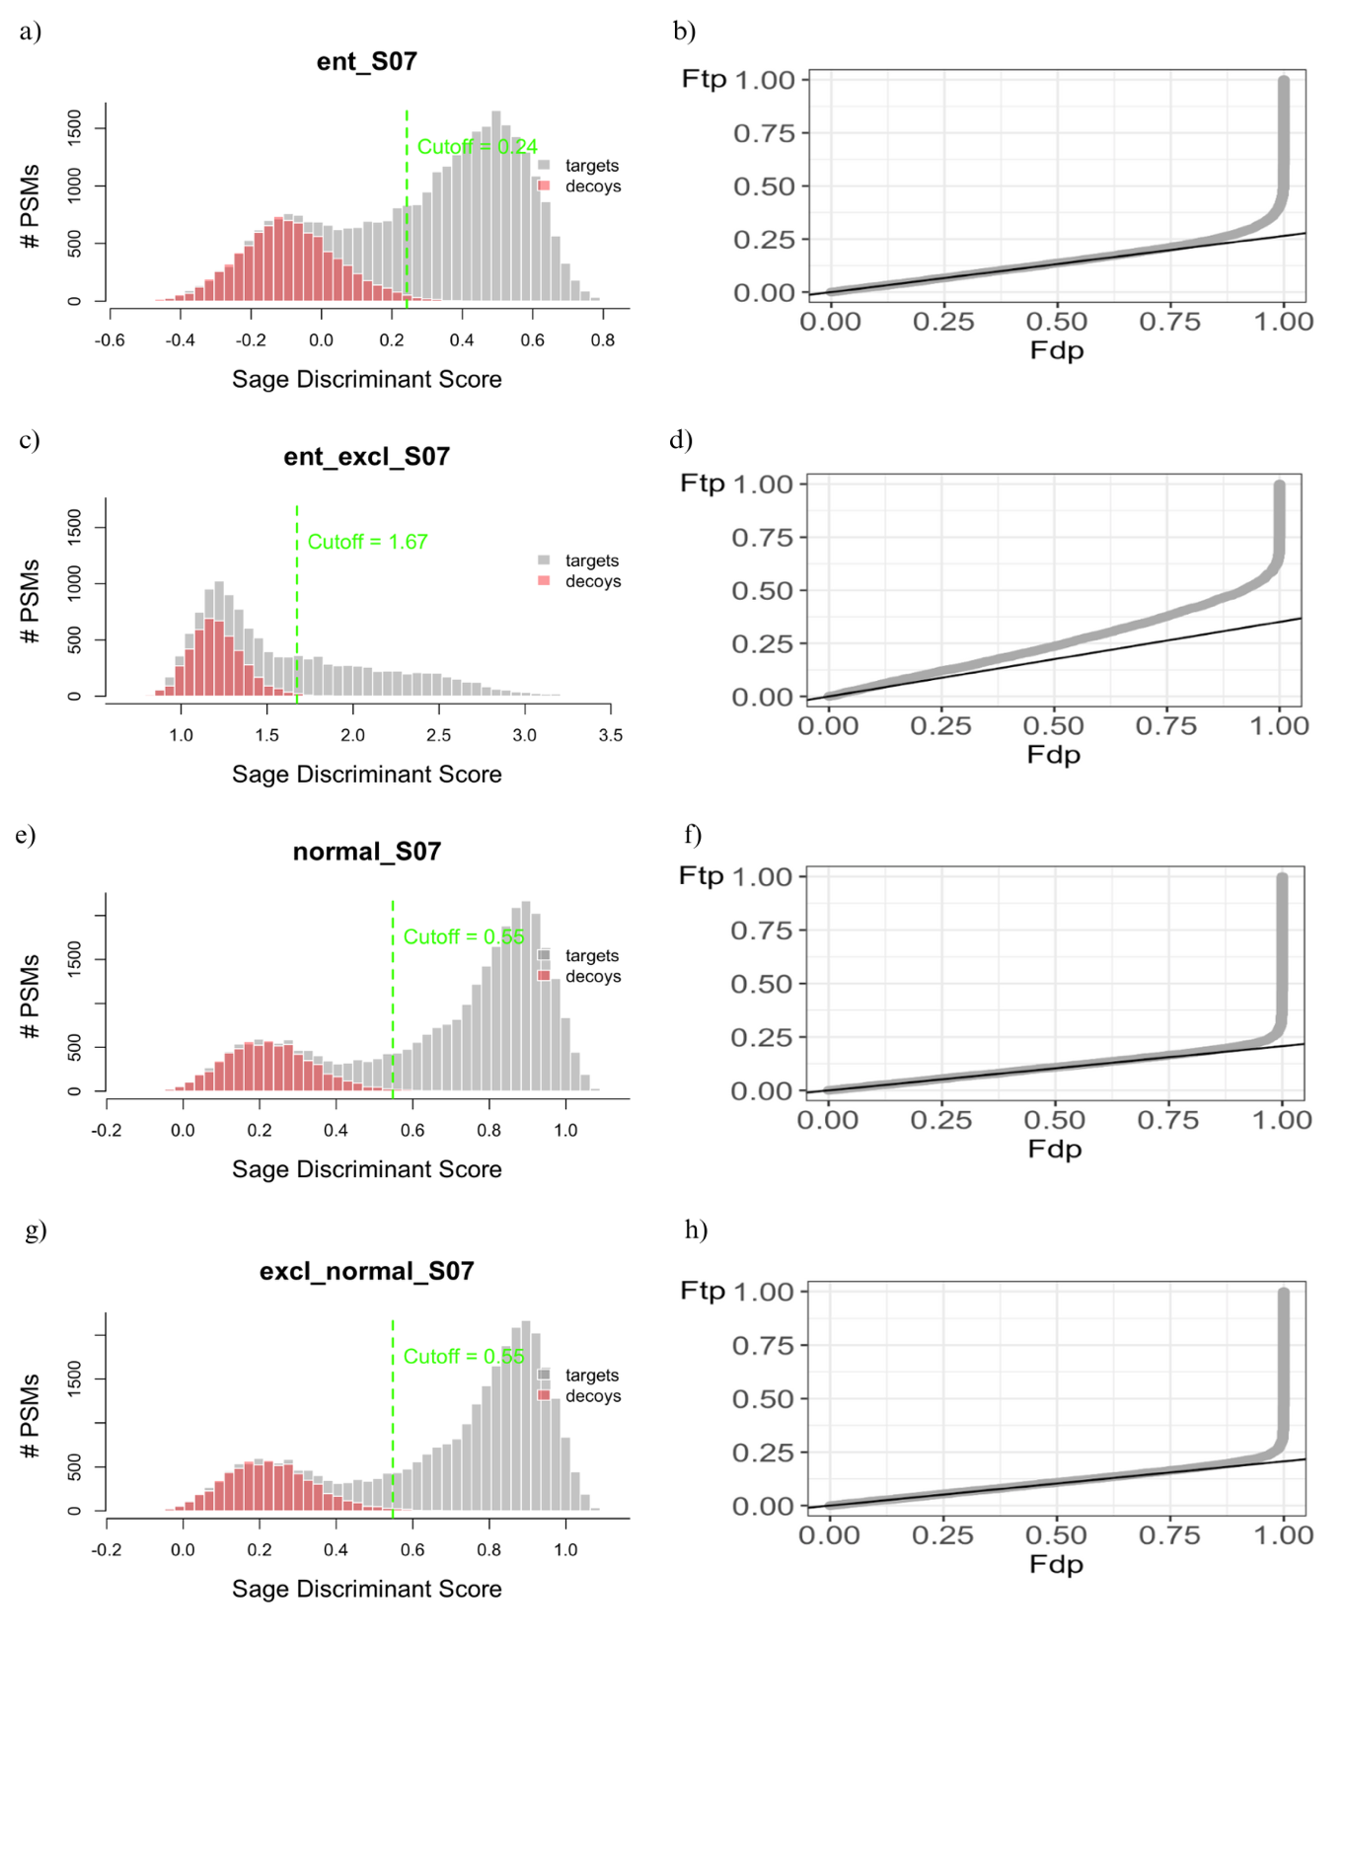

*Figure A7. Validation of target-decoy assumptions for sample S07 across different database scenarios. Left panels show the Sage discriminant score distributions for target (grey) and decoy (red) PSMs; right panels show the corresponding PP plots. ent_S07 refers to the search using the entrapment database including Clostridium butyricum; ent_excl_S07 refers to the same search, but with C. butyricum removed from the database; normal_S07 refers to the standard search without entrapment; and excl_normal_S07 refers to C. butyricum excluded from the normal database. Dashed green lines indicate the 1% FDR cutoff. PP plots evaluate the validity of TDA assumptions (ideal behaviour aligns with the diagonal.*

*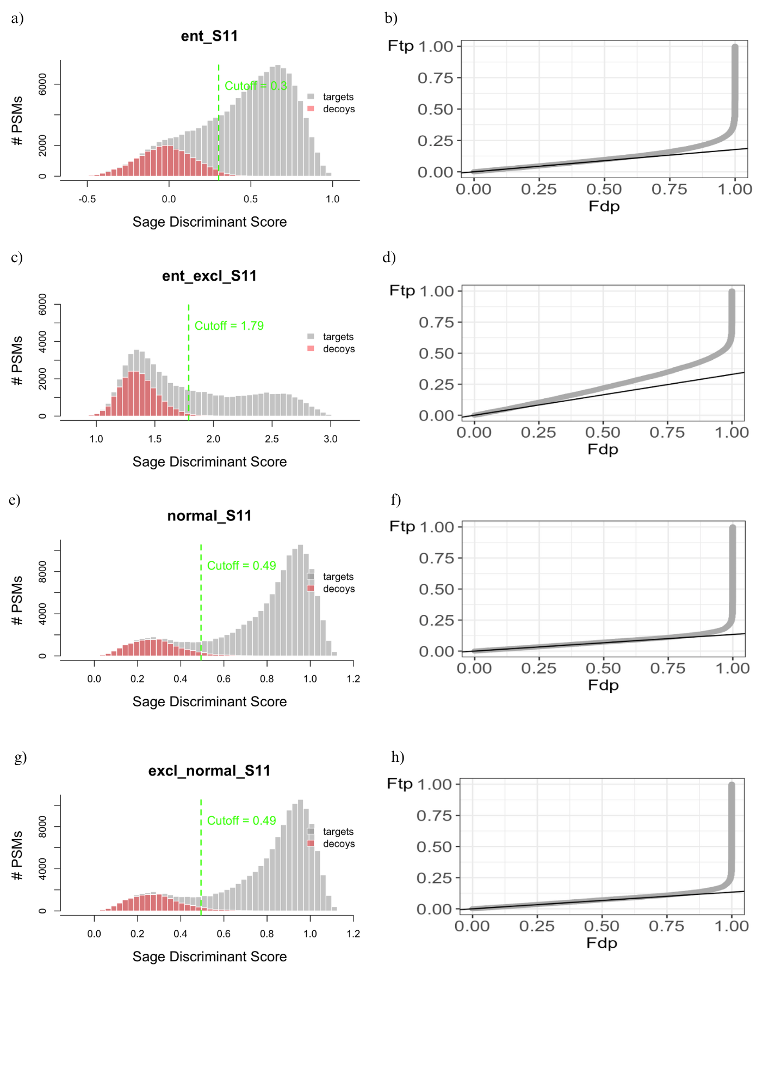Figure A8. Validation of target-decoy assumptions for sample S07 across different database scenarios. Left panels show the Sage discriminant score distributions for target (grey) and decoy (red) PSMs; right panels show the corresponding PP plots. ent_S07 refers to the search using the entrapment database including Clostridium butyricum; ent_excl_S07 refers to the same search, but with C. butyricum removed from the database; normal_S07 refers to the standard search without entrapment; and excl_normal_S07 refers to C. butyricum excluded from the normal database. Dashed green lines indicate the 1% FDR cutoff. PP plots evaluate the validity of TDA assumptions (ideal behaviour aligns with the diagonal.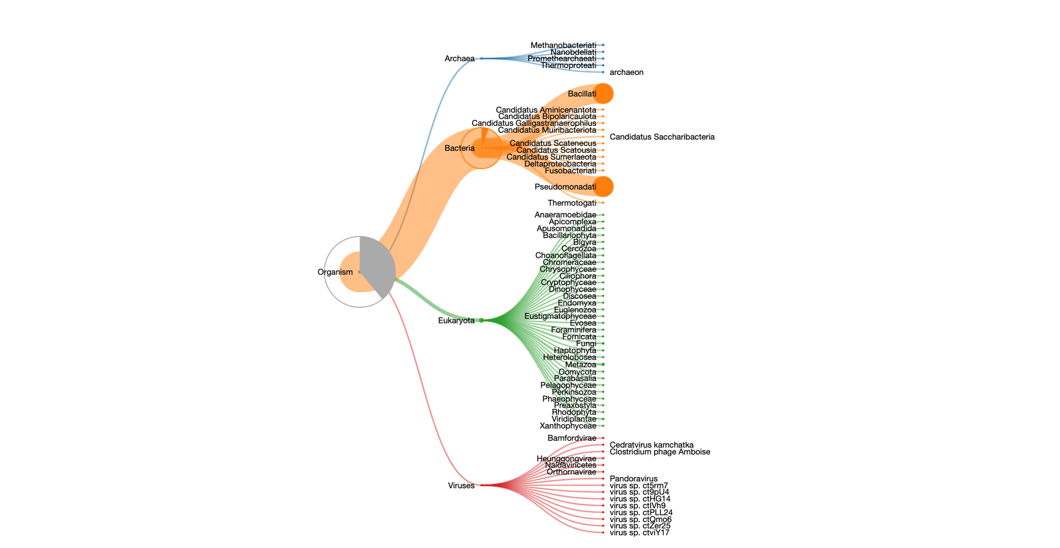Figure A9. Tree of the species identified by UniPept for sample S05.*

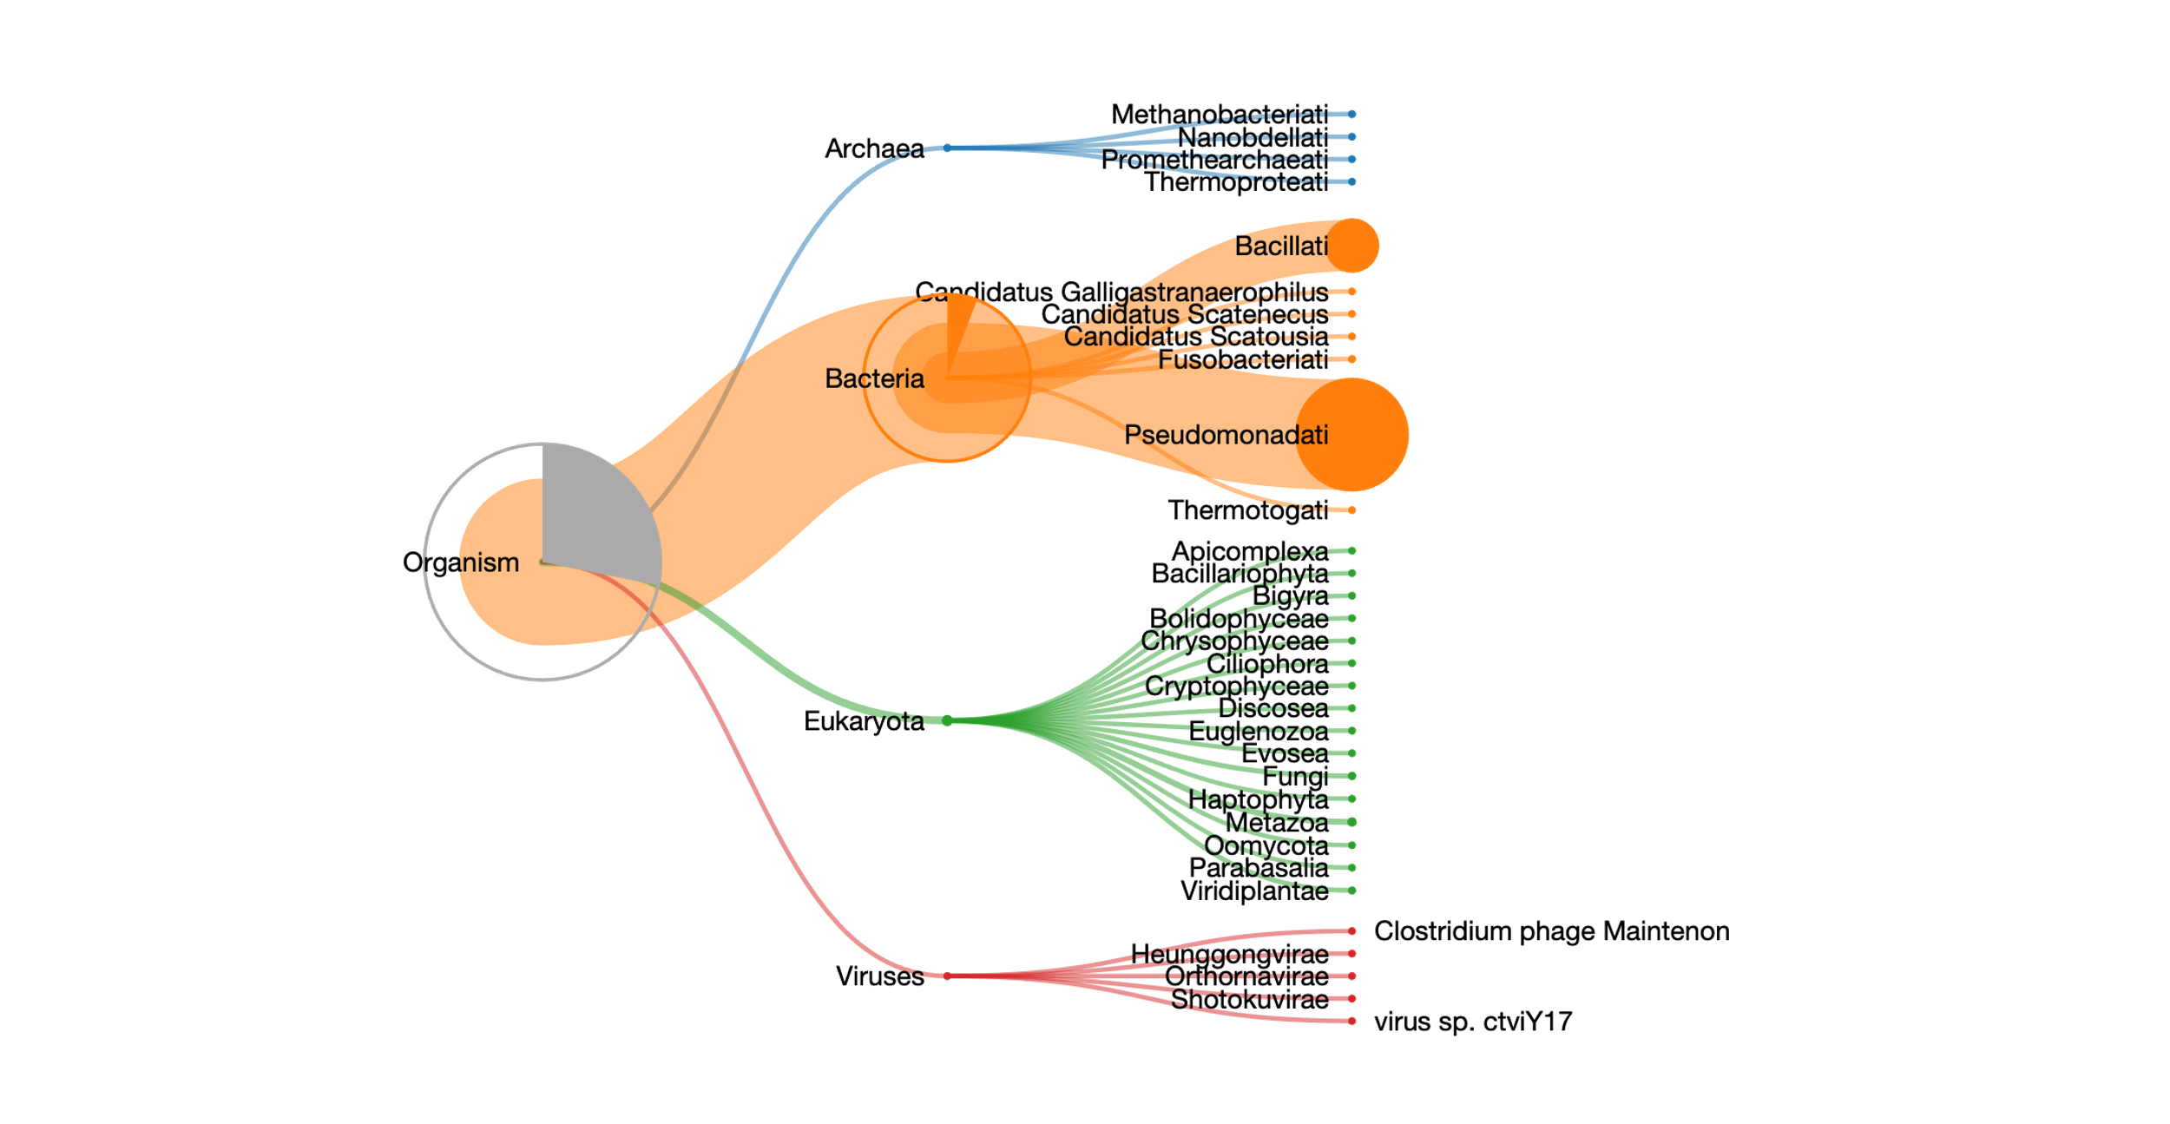*Figure A10. Tree of the species identified by UniPept for sample S07.*

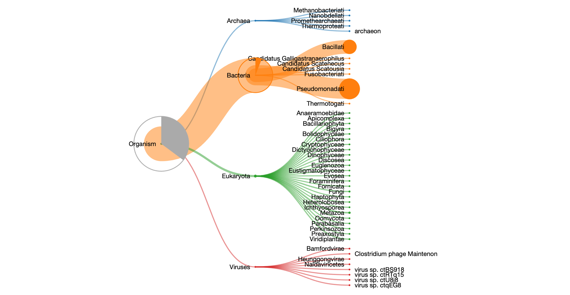

*Figure A11. Tree of the species identified by UniPept for sample S11.*

*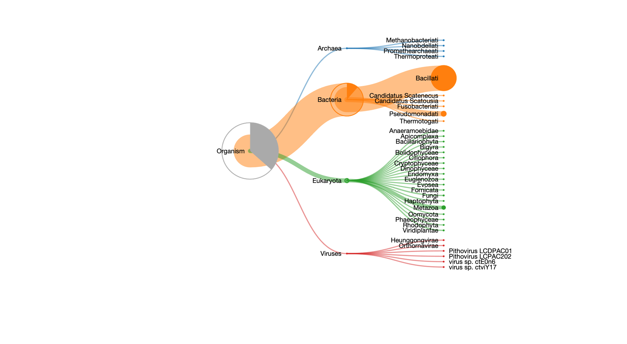Figure A12. Tree of the species identified by UniPept for sample F06.*

*Figure A13. Tree of the species identified by UniPept for sample F07.*

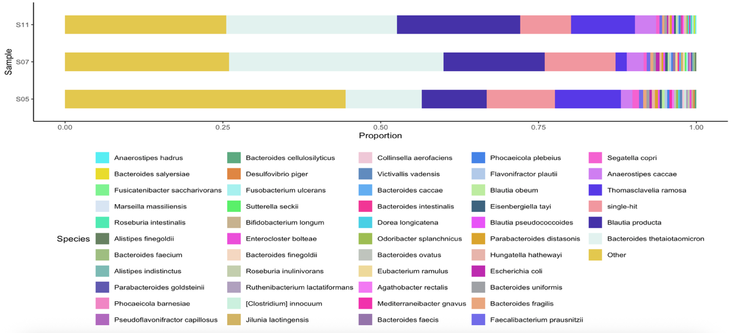

*Figure A14. Barplot showing the species identified in mock community samples using UniPept. The x-axis represents the relative proportion of each species, while the y-axis indicates individual samples. The category “Other” includes all species ranked below the top 30 in abundance, grouped together to maintain readability. “single-hit” species refer to those identified by only one peptide-spectrum match (PSM), often considered low-confidence identifications.*

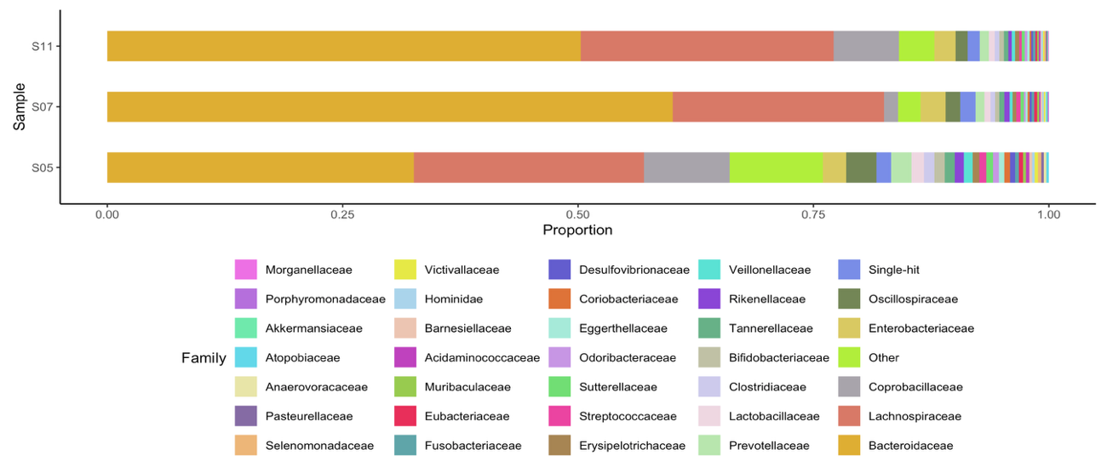

*Figure A15. Barplot showing the families identified in mock community samples using UniPept. The x-axis represents the relative proportion of each family, while the y-axis indicates individual samples. The category “Other” includes all families ranked below the top 30 in abundance, grouped together to maintain readability. “single-hit” families refer to those identified by only one peptide-spectrum match (PSM), often considered low-confidence identifications.*

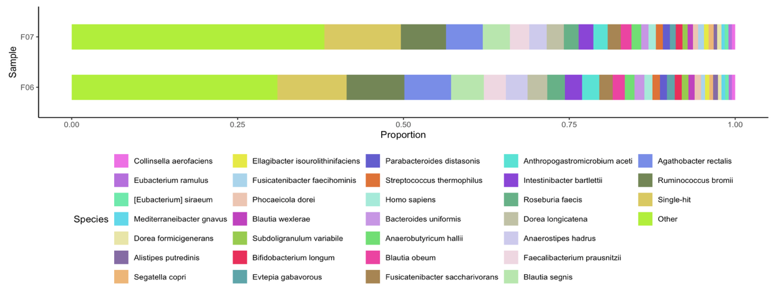

*Figure A16. Barplot showing the species identified in the faecal samples using UniPept. The x-axis represents the relative proportion of each species, while the y-axis indicates individual samples. The category “Other” includes all species ranked below the top 30 in abundance, grouped together to maintain readability. “single-hit” species refer to those identified by only one peptide-spectrum match (PSM), often considered low-confidence identifications*

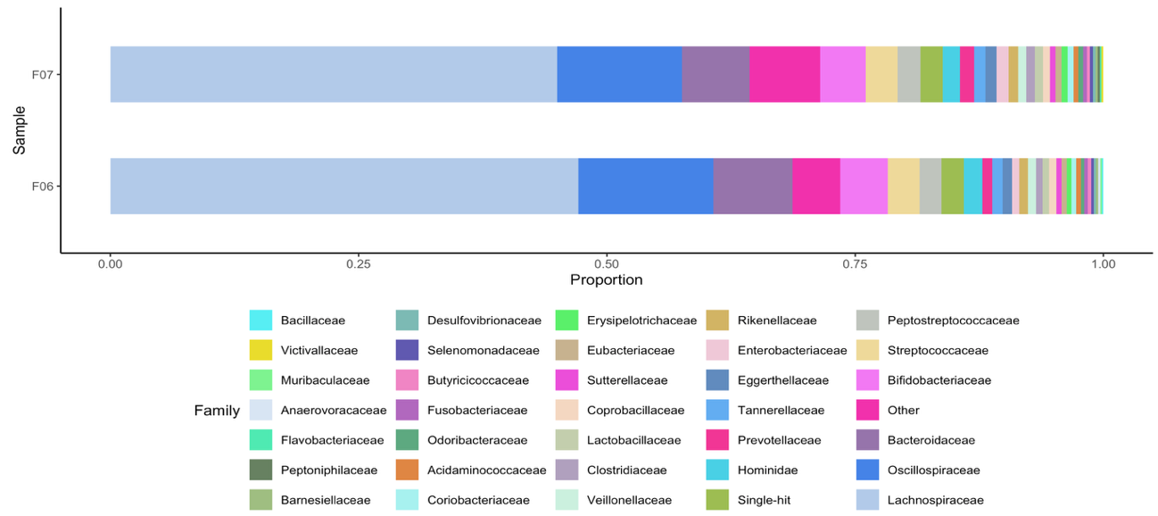

*Figure A17. Barplot showing the families identified in the faecal samples using UniPept. The x-axis represents the relative proportion of each family, while the y-axis indicates individual samples. The category “Other” includes all families ranked below the top 30 in abundance, grouped together to maintain readability. “single-hit” families refer to those identified by only one peptide-spectrum match (PSM), often considered low-confidence identifications.*